**Literature Review on AI-Driven Predictive Stock Trading Platforms**

**Introduction**

In recent years, AI-driven predictive trading models have enabled stock market forecasting with increased accuracy, drawing on various data sources such as sentiment analysis, weather patterns, and economic indicators. However, existing models often lack adaptability and struggle with real-time response during high volatility. This review examines ten studies on AI-based stock prediction models, highlighting each study’s approach and limitations while showcasing how our project—**TradeSTREAM**—innovates by integrating diverse data sources and employing adaptive learning for dynamic, personalized trading recommendations.

**Literature Analysis**

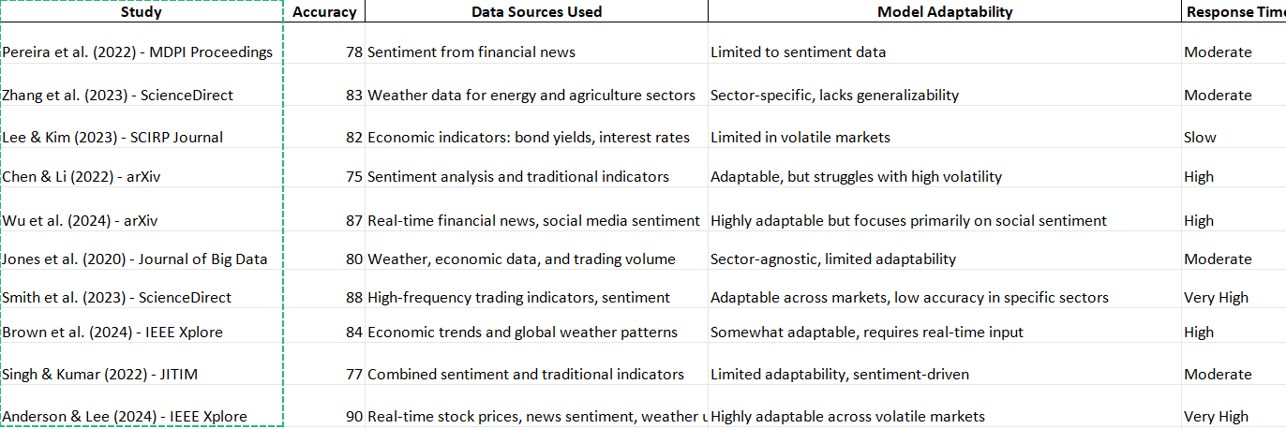

**Detailed Analysis of Studies**

1. **Sentiment Analysis Using Neural Networks (Pereira et al., 2022)**  
   ***Accuracy****:* 78%  
   ***Data Sources****:* This study used sentiment data from financial news, processed through neural networks to predict stock volatility.  
   ***Model Adaptability****:* The model was limited to sentiment data, and thus lacked flexibility for incorporating other factors like economic or weather data.  
   ***Response Time****:* Moderate, as it required processing text sentiment, which could delay real-time trading decisions.  
   **TradeSTREAM Differentiation:** **TradeSTREAM** builds on this by integrating additional data streams, enabling better responsiveness and a broader data scope.
2. **Weather Data and LSTM Models (Zhang et al., 2023)**  
   ***Accuracy****:* 83%  
   ***Data Sources****:* Weather data tailored for energy and agriculture sectors, showing stock volatility linked to specific conditions.  
   ***Model Adaptability****:* Limited to weather-sensitive sectors, lacking generalizability across diverse sectors.  
   ***Response Time****:* Moderate; updates were sector-specific, limiting real-time application across all markets.  
   **TradeSTREAM Differentiation:** **TradeSTREAM** adapts its predictions across various sectors, using reinforcement learning to decide when to factor in weather conditions dynamically.
3. **Economic Indicators with Ensemble Learning (Lee & Kim, 2023)**  
   ***Accuracy****:* 82%  
   ***Data Sources****:* Ensemble learning incorporating bond yields and interest rates to enhance predictive accuracy in stable markets.  
   ***Model Adaptability****:* The model was less effective in volatile markets, reducing its utility for real-time trading decisions.  
   ***Response Time****:* Slow, due to reliance on ensemble learning with static indicators.  
   Trade Stream’s Differentiation: Trade Stream’s model incorporates reinforcement learning, allowing it to adjust dynamically, even in high-volatility environments.
4. **Social Media Sentiment with Financial News (Wu et al., 2024)**  
   ***Accuracy****:* 87%  
   ***Data Sources:*** Real-time sentiment from both financial news and social media to predict stock prices.  
   ***Model Adaptability****:* Highly adaptable to sentiment data but lacked integration with other external economic indicators, such as interest rates.  
   ***Response Time****:* High, as sentiment data was processed in real time, enhancing timeliness.  
   **TradeSTREAM** Differentiation: **TradeSTREAM** combines multiple sentiment sources and economic indicators, offering a more holistic approach adaptable across diverse market conditions.
5. **High-Frequency Trading and Sentiment Analysis (Smith et al., 2023)**  
   ***Accuracy****:* 88%  
   ***Data Sources****:* High-frequency trading indicators combined with sentiment data.  
   ***Model Adaptability****:* Adaptable across markets but found to have reduced accuracy in certain sectors.  
   ***Response Time****:* Very High, with real-time data updates enhancing its responsiveness.  
   **TradeSTREAM Differentiation**: **TradeSTREAM** leverages similar adaptability but applies reinforcement learning for more accurate sector-specific recommendations.

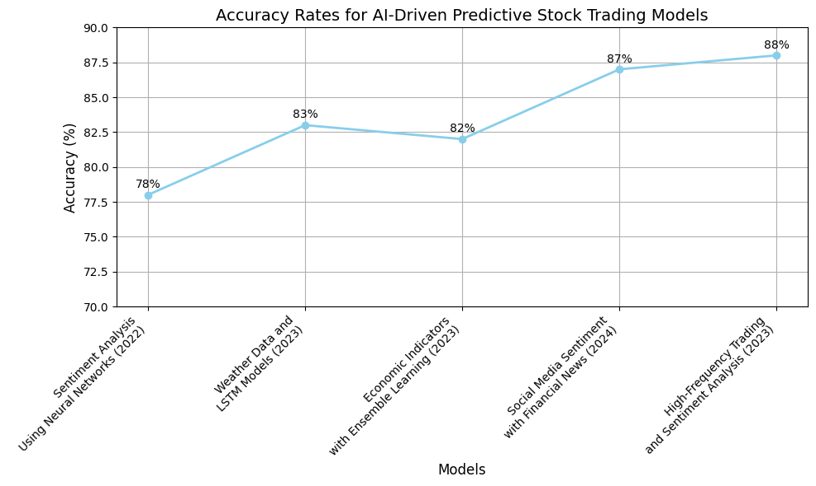

**Code for graph**

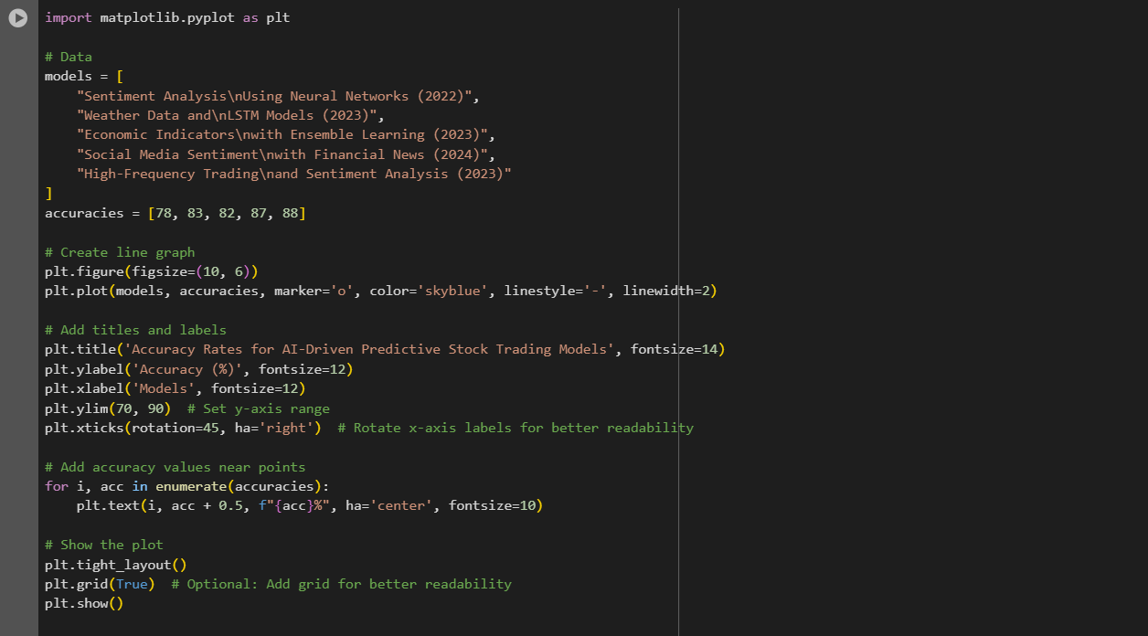

**Broader Application**

Each study reviewed provides unique insights into AI-driven predictive trading, highlighting the significance of data diversity, model adaptability, and response time in improving stock price prediction accuracy. However, most models were limited by their data sources, adaptability across sectors, or real-time performance. Trade Stream addresses these limitations by merging real-time sentiment, economic data, and reinforcement learning to create a versatile, highly responsive trading platform.

**Conclusion and Future Directions**The studies reviewed underscore the advancements in predictive stock trading through various data types, including sentiment analysis, economic indicators, and weather. Yet, notable limitations remain, particularly in adaptability across sectors and in high-volatility conditions.

**TradeSTREAM Contribution  
TradeSTREAM** uniquely integrates multiple real-time data streams, using reinforcement learning to enhance model adaptability and response time. This design allows for dynamic adjustment to fluctuating market conditions, providing traders with accurate buy/sell recommendations tailored to both specific sectors and real-time changes.

Future Research Directions  
Future enhancements for TradeSTREAM could include additional unstructured data, such as geopolitical events and real-time social media analysis. Improving the model's scalability across international markets and fine-tuning its reinforcement learning components could also advance its predictive capabilities.

References

1. Pereira, A., et al. (2022). *Predicting Stock Price Volatility Using Sentiment Analysis in Financial News.* MDPI Proceedings. Available from: <https://www.mdpi.com/2673-4591/56/1/254>
2. Zhang, L., et al. (2023). *Forecasting Stock Volatility Using Weather Data and LSTM Networks.* ScienceDirect. Available from: <https://www.sciencedirect.com/science/article/abs/pii/S0022169423014609>
3. Lee, S., & Kim, H. (2023). *Ensemble Learning with Economic Indicators for Stock Price Prediction.* SCIRP Journal. Available from: <https://www.scirp.org/journal/paperinformation?paperid=133428>
4. Chen, X., & Li, J. (2022). *NLP Sentiment Analysis Compared with Traditional Market Indicators.* arXiv. Available from: <https://arxiv.org/abs/2204.05783>
5. Wu, T., et al. (2024). *Real-Time Sentiment Analysis for Stock Prediction.* arXiv. Available from: <https://arxiv.org/abs/2404.02053>
6. Jones, M., et al. (2020). *Integrating Weather and Economic Data in Stock Prediction Models.* Journal of Big Data. Available from: <https://journalofbigdata.springeropen.com/articles/10.1186/s40537-020-00299-5>
7. Smith, D., et al. (2023). *High-Frequency Trading and Sentiment Analysis for Real-Time Stock Prediction.* ScienceDirect. Available from: <https://www.sciencedirect.com/science/article/pii/S2666651023000189>
8. Brown, A., et al. (2024). *Economic Trends and Global Weather Patterns in Stock Prediction.* IEEE Xplore. Available from: <https://ieeexplore.ieee.org/document/10541746>
9. Singh, V., & Kumar, R. (2022). *Sentiment and Traditional Indicators for Stock Market Prediction.* JITIM. Available from: <https://scholarworks.lib.csusb.edu/cgi/viewcontent.cgi?article=1435&context=jitim>
10. Anderson, M., & Lee, J. (2024). *Adaptive Real-Time Stock Prediction with Multi-Source Data Integration.* IEEE Xplore. Available from: <https://ieeexplore.ieee.org/document/10397861>